4 Steps to Sales Training That Delivers ROI
Steven Rosen, MBA

Despite the economic downturn progressive sales organizations are continuing to invest 2-5% of their annual sales budgets in sales training and development. These organizations undoubtedly will outperform their competitors who don’t invest. Training and development is one of the key factors that lead to improved sales performance.

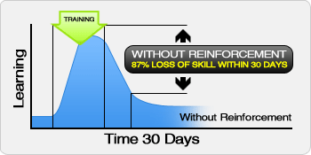
The problem is that 90% of sales training is a waste of time and money. Most sales training is an event. It may increase sales force engagement but has little lasting impact. Without effective reinforcement the impact of your training will be lost within 30 days. The basis of reinforcement comes from sales managers coaching reps, post-training.

Post-training sales coaching and reinforcement is the key to sustaining your sales training investment. We know that coaching is the No. 1 sales management activity that drives sales performance. Studies reinforce this by showing that above-average coaches deliver 20% more sales. The challenge is that sales coaching is the weakest-performing activity among managers.

Before you invest $1 in training you need to find out how effective your sales managers are at coaching in order to maximise your sales training investment. In fact if you only had $1 to invest I would suggest that you would get the biggest ROI on training your sales managers to be great coaches. Not only will you get better sales results, you will also better leverage additional training investment.

The 4-step process outlined below will give you insight in how to maximise any training investment. The example I use is based on Best Practices For Training Sales Managers to be great coaches. This model is applicable for all training.

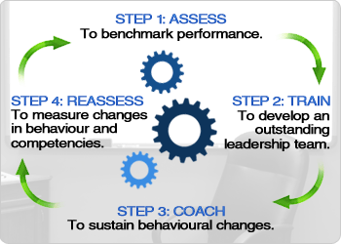
Four Step Training Model:

Step 1: Assessing Skills and Behaviors

Assuming you already know what you want to achieve with your training investment (i.e., develop “great sales coaches”) you need to find out where you are before you embark on your journey. It is important to understand the skill level of the people you are training. Many tools can be used to benchmark skills, like 360-degree review. We have developed the Sales Manager Coaching Assessment which benchmarks each sales manager on 6 dimensions of effective coaching. You can also benchmark the level of sales rep engagement in each district as a starting base.

STEP 2: Delivery of Training

Once you have benchmarked the level skill/behaviors/competencies, there are several ways to make the actual delivery of training more impactful. Assign participants advanced reading and other pre-work so they will come to the training with a base level of knowledge as well as some exposure to the content beforehand. Role-playing and case studies allow for real-life application of the learning, which improves understanding and applicability. Trainers who are dynamic and create a high-impact learning environment add to the training experience.

Most trainers will do a “happy face” post-training questionnaire to gauge their effectiveness. All this does is allow them to pat themselves on the back and check the box that they have delivered effective training. As I stated earlier, the impact of training delivered by the best trainers is lost within 30 days without proper reinforcement.

Step 3: Reinforcement to sustain skills/behavior/competency changes
When sales reps take a training course the responsibility for reinforcement lies with their district sales managers. What happens when a district sales manager is trained? Who is responsible for reinforcing the training? Will the VP of Sales do it? Will the trainer be responsible? If no one does it you can kiss your training dollars good bye.

I have spent a lot of time developing effective reinforcement skills/behaviors/competencies for post-training learning. In the diagram below it is clear that effective training that includes reading, audio visual presentation/lecture and some demonstration will produce knowledge retention of at least 30%.

How do you ensure that you move the retention rate closer to 100%?

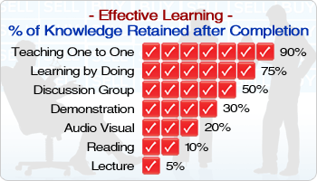
I use a multi-pronged approach to ensure that post training reinforcement leads to effective learning and creates sustainable changes in skills, behaviors or competencies. 1-on-1 coaching with a sales management coach is by far the best way to ensure effective results for your training investment. Sharing best practices and discussing challenges with peers in monthly facilitated group tele-sessions has great benefit as well. Lastly, coaching the VP of Sales to effectively role-model and support the training completes the reinforcement process. The bottom line is that coaching reinforces training to establish permanent skill and behavioral changes.

STEP 4 – Reassessing Skills and Behaviors

Six to nine months down the road we reassess the level of skills/competencies /behaviors using the same tool we used up front. This step serves several purposes. First, when training participants know they will be held accountable to demonstrate behavioral/skill/competency development post- training and that they will be measured, you get better results. Second, it allows management to gauge the impact of their investment in training.

This four-step process is the best way to ensure you maximise the ROI of your training dollars.

Steven Rosen, MBA is a sales management expert who helps companies transform sales managers into great sales coaches. Steven works with sales executives to hire top-performing sales reps and managers, develop their teams into top sales managers and achieve greater personal and professional success.

He is the CEO of STAR Results and author of many articles in the areas of sales management coaching and sales management training. He is a member of Top Sales Experts, an international online community of many of the world’s leading sales and business gurus. Steven’s mission is to inspire sales leaders, managers and salespeople to achieve their full potential. He can be reached at steven@starresults.com or 905-737-4548.

Keywords: sales training, sales manager coaching, sales management training, executive coaching, Steven Rosen

http://www.starresults.com/blog/?p=255

